Each year Sigma “travels” to 4 countries—1 in Asia, 1 in Africa, 1 in Europe and 1 in the Americas. This past year we learned about Japan, Zimbabwe, Norway, and Bolivia. Our sister, Susan, researches each country and puts the information on cards which are read orally at our meeting. The information includes geography, history, the exports of the country, landmark places, and unusual, sometimes quirky, facts. The final card is information on the craft we will be making. Each craft is either a representation of that country’s art, or art which depicts a part of the culture of the country.

For Japan we made landscapes as a form of Chigiri-e which uses torn handmade paper to create pictures which look like watercolors.

Bolivians put decorative tassels on their llamas to tell them apart, often adding additional décor. So, we decorated our llamas appropriately.

The women of the Ndebele tribe in Zimbabwe paint their houses with geometric designs and vivid colors and we created ours.

Sigma has been learning about different countries since 2014 and we each have a better understanding of our world plus unique pieces of art.

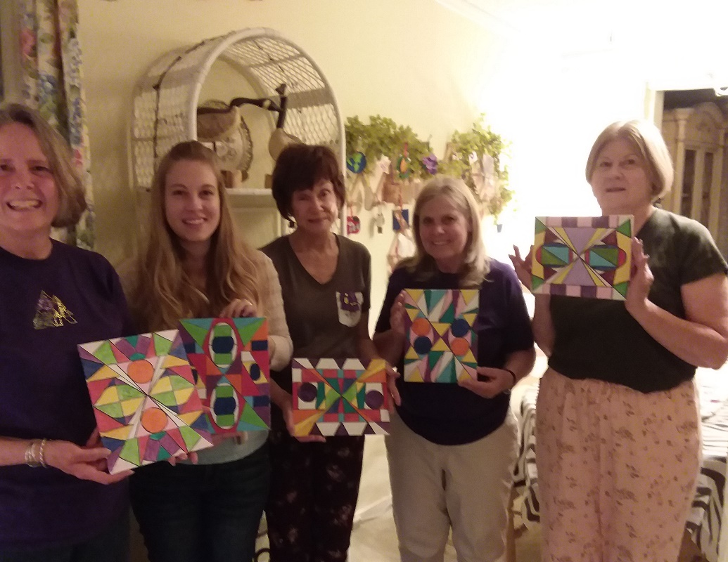

Bobbie Benitez, Sara Ortega, Joy Goodsell,
Lynn Ramsey, Susan Naegle with Ndebele art

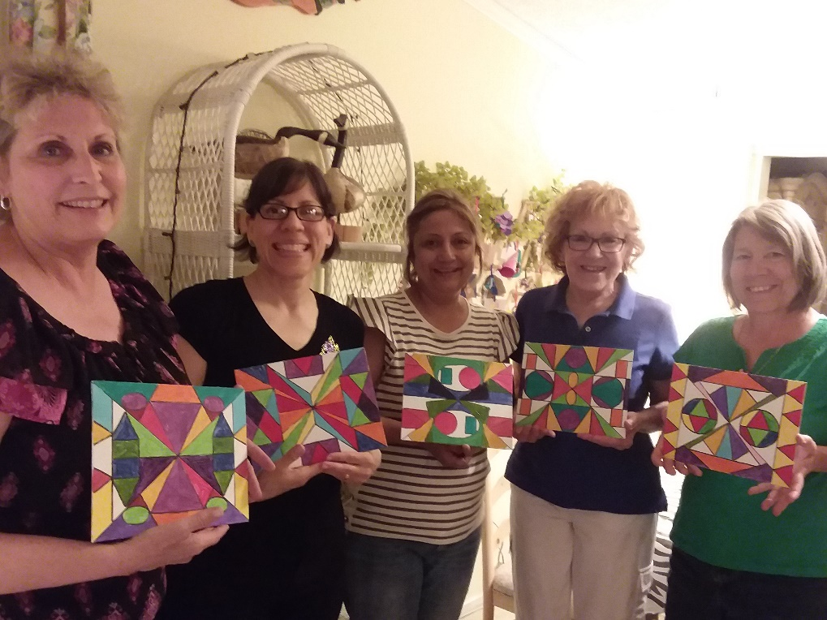

Linda Brady, Robin Leebardt, Gina Georgelos,
Alice Bever, Tammy Christopherson with their art
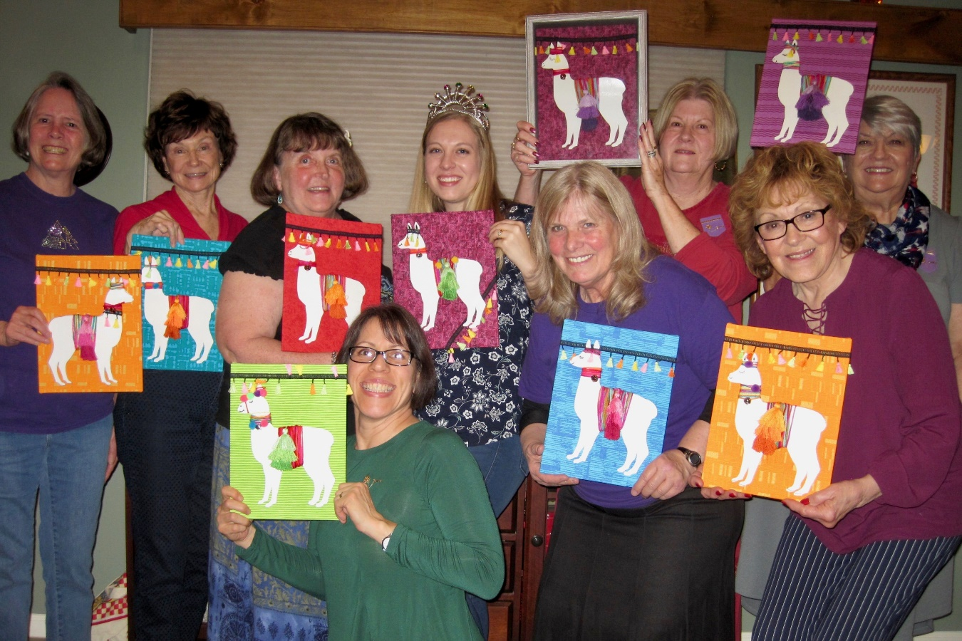
Bobbie Benitez, Joy Goodsell, President Betty Ehret, Sara Ortega, Susan Naegle, Historian Mary Henderson in the back row. Robin Leebardt, Lynn Ramsey, Alice Bever in front.
OUR FABULOUS LLAMAS

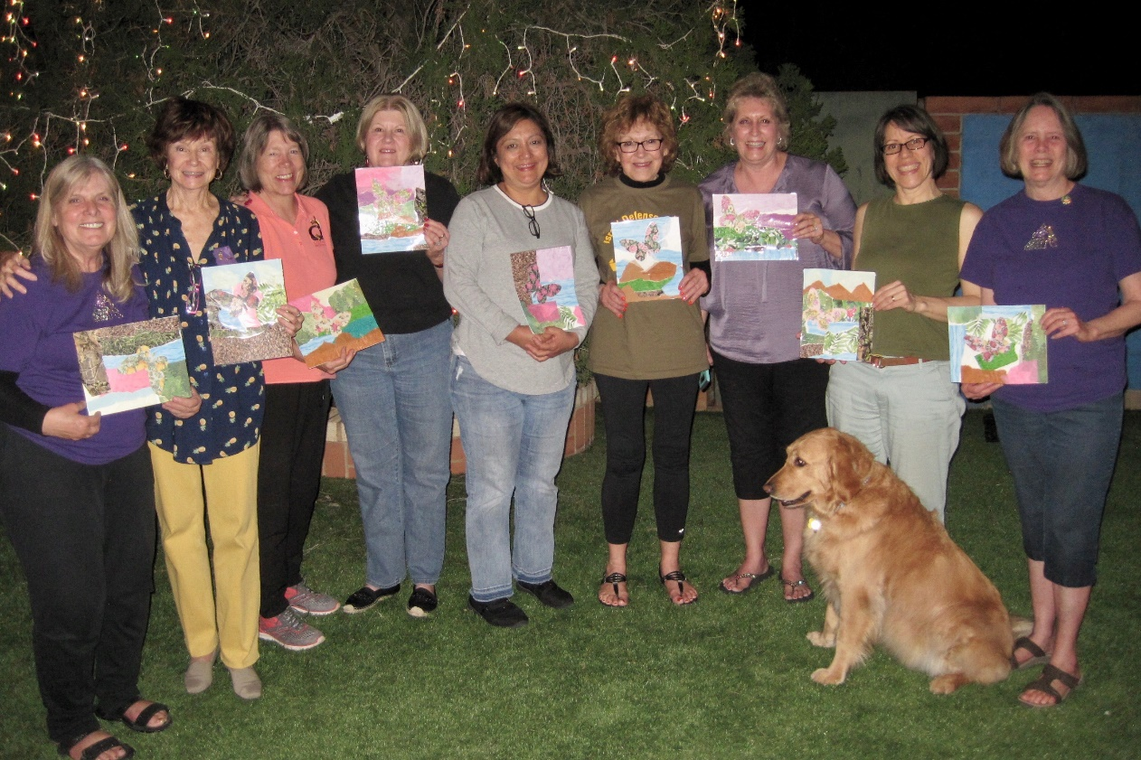

Lynn Ramsey, Joy Goodsell, Tammy Christopherson,
Susan Naegle, Gina Georgelos, Alice Bever, Linda Brady,
Robin Leebardt, and Bobbie Benitez show off their
Japanese Art. (Sarah the dog did not participate)

