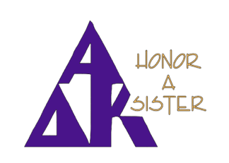
Honoring an AZ Sister
The AZ Scholarship Fund is the state’s Altruistic Project for this biennium to help support our Scholarship fund. the state board encourages you to HONOR an AZ SISTER through your donations. It could be in memory of an Omega sister or thanking your Chapter President for her leadership. Donations may be sent to President Kristi or Treasurer Chris Sanzo. A note of acknowledgement for the donation will be sent to the recipient or the family of an Omega sister.

Kristi Koziol AZ President 2222 E Shea Blvd Phoenix AZ 85028
Chris Sanzo AZ Treasurer 10571 E Sunnywood Dr Tucson AZ 85749

**********************************************
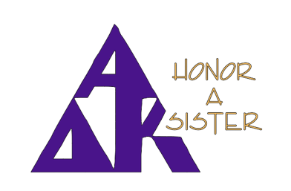

Donor’s name (you) _________________________________

Chapter _________________________________

Amount of Donation for the AZ Scholarship Fund _________

Name of who donation is honoring _______________________________

Reason __________________________________________________________
Contact information
Address __________________________________________________________

Mail to
Kristi Koziol AZ President 2222 E Shea Blvd Phoenix AZ 85028 or
Chris Sanzo AZ Treasurer 10571 E Sunnywood Dr Tucson AZ 85749

